**SUMMARY** **REPORT**

**ASSIGNMENT-2**

**Overview:**

The IMDB dataset was employed to evaluate several neural network configurations in this exercise, including adjustments to the hidden layers, hidden units, functions for activation, and loss functions. Even with regularization. After a few epochs, the model demonstrated indications of overfitting due to methods like L2 regularization and Dropout, as the validation loss started to increase and the validation accuracy plateaued.

**1.Two hidden layers were employed. Examine the effects of employing a few or many hidden layers on test accuracy and validity.**

One Hidden Layer

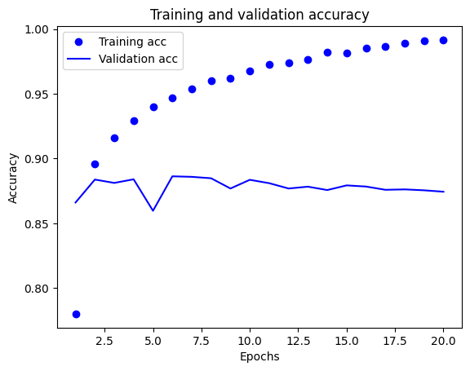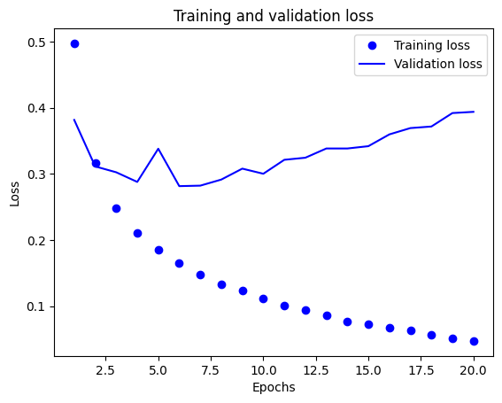

• Training Accuracy: The model's accuracy on the training set was around 99.6% by the end of the epoch.

• Validation Accuracy: At 88%, the validation accuracy peaked.

• Training and Validation Loss: Although the training loss steadily declined, there were still some variations in the validation loss, which may indicate overfitting.

**3 hidden Layers**

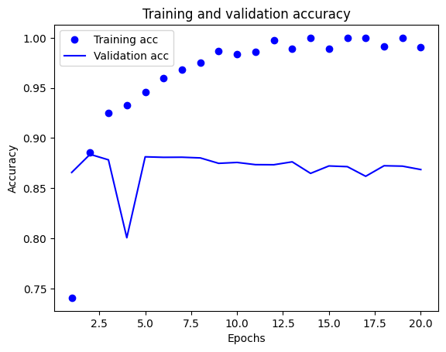

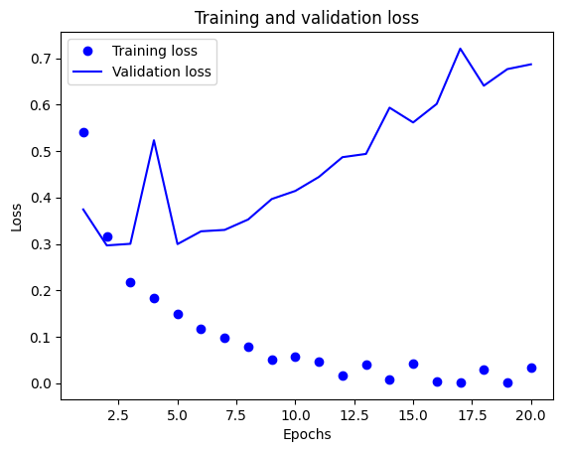

**3 hidden Layers**

• Training Accuracy: The model demonstrated a strong fit to the training information with an accuracy of 99.7%.

• Validation Accuracy: Although it peaked at roughly 88.4%, the validation accuracy was marginally lower compared to the instance of the model with one hidden layer.

• Validation Loss: The model may have overfit to the training data, as evidenced by validation loss becoming unstable, especially in the latter stages.

**2. Try using layers with more hidden units or fewer hidden units: 16units, 32 units, 64 units, and so on.**

There are 16 less hidden units.

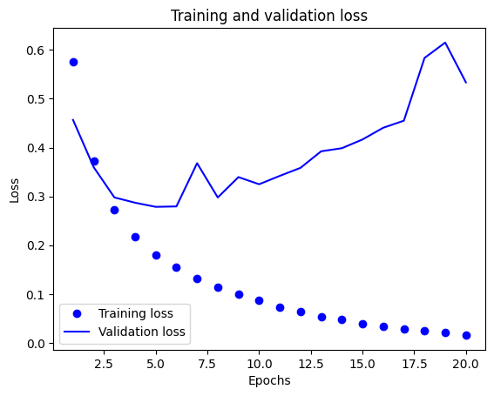 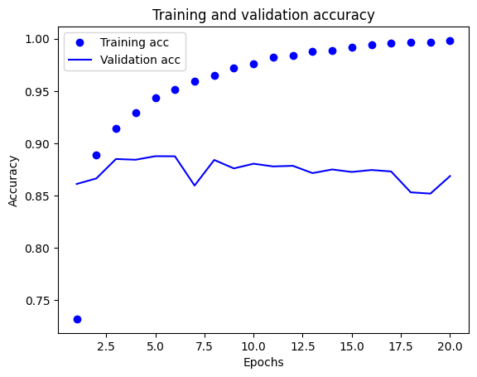

Fewer Hidden Units (16 units)

• Training Accuracy: The model attained a training accuracy of 99.94%.

• Validation Accuracy: The highest validation accuracy reached approximately 87.8%.

• Loss: The training loss steadily decreased, while the validation loss exhibited fluctuations, ending at about 0.6198.

**Fewer Hidden Units (32 units) :**

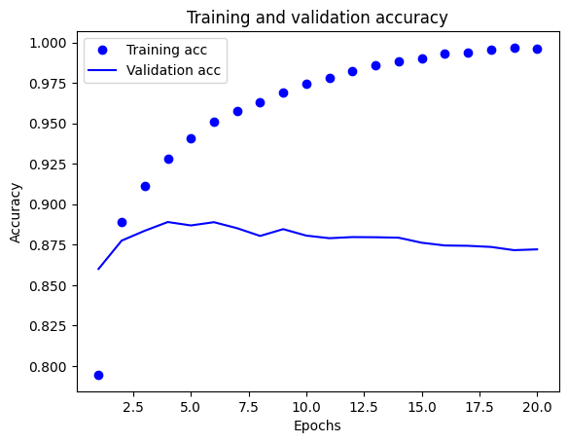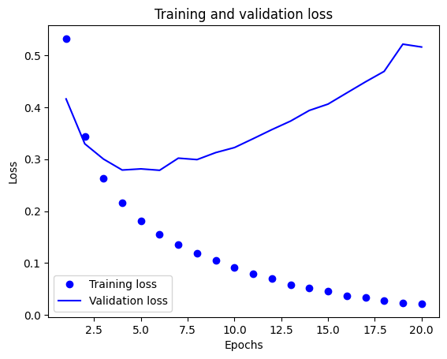

Fewer Hidden Units (32 units)

• Training Accuracy: The model attained a training accuracy of 99.98%.

• Validation Accuracy: The highest validation accuracy reached approximately 88.7%.

• Loss: The training loss steadily decreased, while the validation loss exhibited fluctuations, ending at about 0.6196.

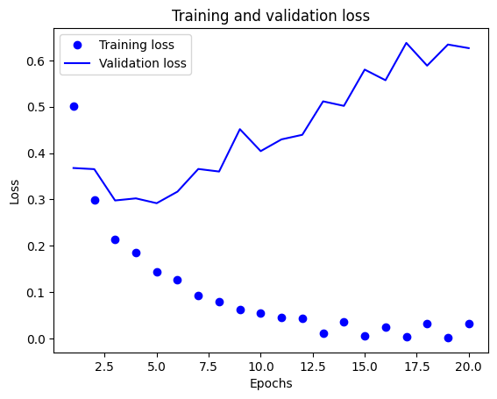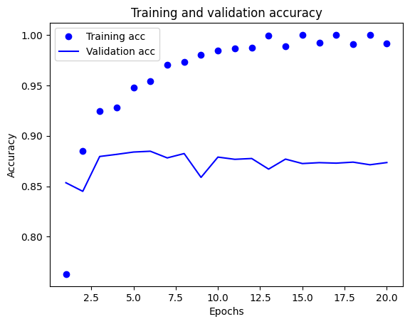 **More Hidden Units (64 units) :**

• Training Accuracy: By the last epoch, training accuracy had reached the full amount.

• Validation Accuracy: The model with fewer units had a slightly higher validation accuracy, peaking at roughly 88.6%.

• Loss: With a final loss value of approximately 0.6088, the validation loss displayed moderate inconsistency.

**Observations**

1. Overfitting: The difference between training and validation accuracy showed that both models were overfit, especially the model with more units that attained flawless training accuracy.

2.Loss Stability: Compared compared to the model with more hidden units, the one with fewer hidden units showed a little more stable loss trajectory.

Training Accuracy: The model's maximum training accuracy was approximately 99.4 per cent according to the training results.

**3.Try using the mse loss function instead of binary_crossentropy**.

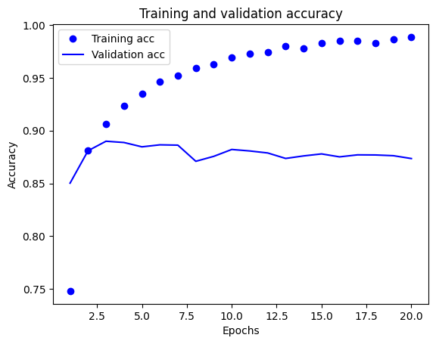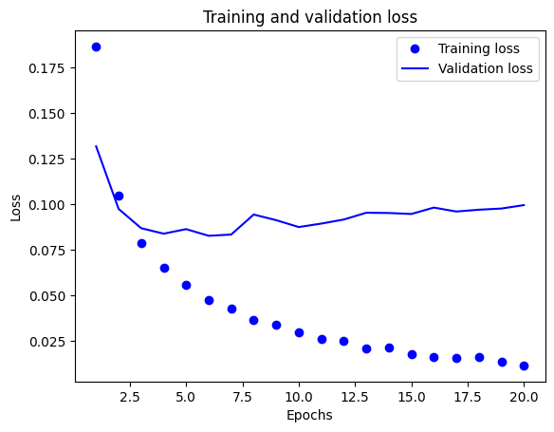

Training Results

• Training Accuracy: The model reached a maximum training accuracy of about 99.5%.

• Validation Accuracy: About 88.7% was the highest validation accuracy.

• Training Loss: By the end of development, the training loss had steadily dropped to about 0.0136.

• Validation Loss: The validation loss ended at roughly 0.0999 after exhibiting slight oscillation. Observations

1. Performance with MSE: MSE can be used for binary classification but it is primarily designed for regression problems. Its precision might not be as good as that of binary cross-entropy, though.

2. Validation Stability: Over the epochs, there were no appreciable gains in validation accuracy, but it remained rather constant.

3. Overfitting: This model, like earlier models, shows evidence of overfitting, as evidenced by a significantly greater training accuracy than validation accuracy.

**4 .Try using the tanh activation (an activation that was popular in the early days of neural networks) instead of relu**.

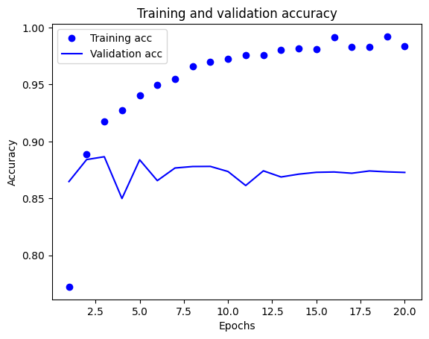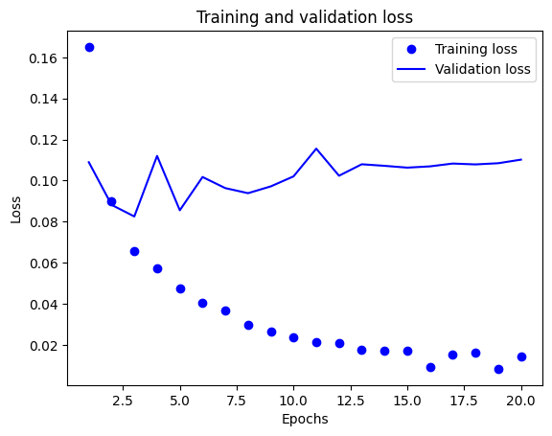

Training Outcomes

• Accuracy of Training: Achieved a maximum accuracy of around 99.2%.

• Validation Accuracy: Approximately 88.1% was the best validation accuracy.

• Training Loss: By the conclusion, training loss had steadily dropped to about 0.0229.

• Validation Loss: About 0.1103 was the final validation loss.

**Observations**

1. Tanh vs. ReLU: Because the tanh activation function generates outputs between -1 and 1, it is effective than ReLU at mitigating issues associated with dying neurons. However, the initialization and scaling processes for the inputs may still have an impact on its performance.

2. Validation Stability: Like earlier models, the validation accuracy displayed slight variations, suggesting a steady performance with potential for improvement.

3. Overfitting: The validation accuracy does not match the training accuracy as closely, indicating that some overfitting may still be taking place even while the training accuracy stays high.

**5. Use any technique we studied in class, and these include regularization, dropout, etc., to get your model to perform better on validation**.

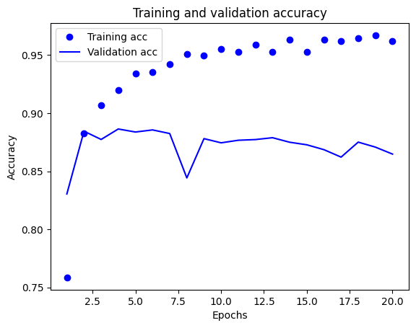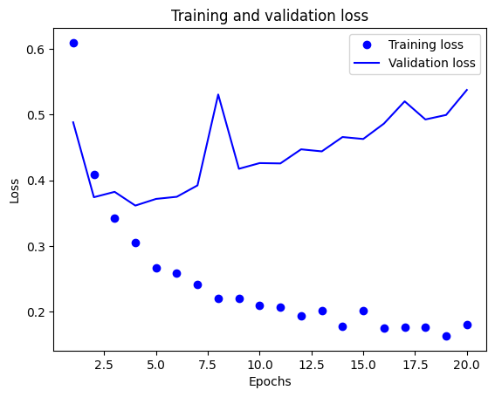

Training Outcomes

• Training Accuracy: Reached a peak of approximately 97.5%.

• Validation Accuracy: About 88.1% was the best validation accuracy.

• Training Loss: Finalized at around 0.1584, declining gradually.

• Validation Loss: Reached 0.5146 or such.

**Observations**

1. Dropout Effect: fortunately there was no discernible improvement in validation performance, the application of dropout appears to stabilize the validation accuracy when compared to earlier models.

2. Validation oscillations: Despite the use of regularization and dropout, the reduction in validation shows some oscillations, suggesting that the model still overfits.

3. L2 Regularization: This method has helped to lower the loss and maintain a good validation accuracy, but more tweaks (such changing the regularization intensity) might produce better results.

**Although** all models experienced overfitting, overall performance was comparable for models with fewer and more hidden units, with no discernible benefits from increasing the number of hidden units. When compared to the binary cross model, the model with MSE as the loss function performed somewhat worse. entropy, whereas the relu-based model and the one with the tanh activation function both had comparable results.